SIMATS ENGINEERING

ASSESSMENT TOOL 1

COURSE NAME: Database Management Systems Name:Mukesh Raj(192571036)

COURSE CODE: CSA05

COURSE OUTCOME COVERED

CO1: Analyze DBMS architecture, different data models, schema types, and design ER/EER diagrams, relational schemas for case-based scenarios by identifying entities and relationships. (BL1, BL2)

Activity Tool : Short Answer Text(High) Assessment Tool Weightage: 30%

QUESTIONS Total Marks: 50
Q.N  o | Question | Bloom's Level | Marks
1 | UPS Product Tracking Information System  UPS prides itself on having up-to-date information on the processing and current location of each shipped item. To do this, UPS relies on a company-wide information system. Shipped items are the heart of the UPS product tracking information system. Shipped items can be characterized by item number (unique), weight, dimensions, insurance amount, destination, and final delivery date. Shipped items are received into the UPS system at a single retail center. Retail centers are characterized by their type, uniqueID, and address. Shipped items make their way to their destination via one or more standard UPS transportation events (i.e., flights, truck deliveries). These transportation events are | BL1 –  Remember | 5

 | characterized by a unique scheduleNumber, a type (e.g, flight, truck), and a deliveryRoute. Create an Entity Relationship diagram that captures this information about the UPS system.
2 | Course Management System  Consider a university database for the scheduling of classrooms for final exams. This database could be modeled as the single entity set exam, with attributes course-name, section-number, room-number, and time. Alternatively, one or more additional entity sets could be defined, along with relationship sets to replace some of the attributes of the exam entity set, as  - course with attributes name, department, and c-number  - section with attributes s-number and enrollment, and dependent as a weak entity set on course  - room with attributes r-number, capacity, and building Show an E-R diagram illustrating the use of all three additional entity sets listed. | BL2 –  Understand | 5
3 | University Registrar’s Office Management System  A university registrar’s office maintains data about the following entities:  - courses, including number, title, credits, syllabus, and prerequisites;  - course offerings, including course number, year, semester, section number, instructor(s), timings, and classroom;  - students, including student-id, name, and program;  - instructors, including identification number, name, department, and title.  - Further, the enrollment of students in courses and grades awarded to students in each course they are enrolled for must be appropriately modeled.  Construct an E-R diagram for the registrar’s  office. | BL2 –  Understand | 5

4 | Hospital Management System  Construct an E-R diagram for a hospital with a set of patients and a set of medical doctors.  Associate with each patient a log of the various tests and examinations conducted. Construct appropriate tables for the above ER Diagram :  Patient(SS#, name, insurance) Physician ( name, specialization) Test-log( SS#, test-name, date, time)  Doctor-patient (physician-name, SS#) Patient-history(SS#, test-name, date) | BL2 –  Understand | 5
5 | Company Project Management System  Construct an ER Diagram for Company having following details :  Company organized into DEPARTMENT. Each department has unique name and a particular employee who manages the department. Start date for the manager is recorded. Department may have several locations.  • A department controls a number of PROJECT. Projects have a unique name, number and a single location.  • Company’s EMPLOYEE name, ssno, address, salary, sex and birth date are recorded. An employee is assigned to one department, but may work for several projects (not necessarily controlled by dept). Number of hours/week an employee works on each project is recorded; The immediate supervisor for the employee.  • Employee’s DEPENDENT are tracked for health insurance purposes (dependentname, birthdate, relationship to employee). | BL2 –  Understand | 5
6 | Explain schema and instance with examples. Distinguish between logical schema, physical schema, and view schema. | BL1 –  Remember | 5
7 | Identify the entities, attributes, and relationships for a Bank Management System and construct its ER diagram. | BL2 –  Understand | 5

8 | Explain the Extended ER (EER) model. Describe the concepts of generalization, specialization, and aggregation. | BL2 –  Understand | 5
9 | Design an EER diagram for a Hospital Management System incorporating inheritance and weak entities. | BL2 –  Understand | 5
10 | Explain the role of a DBA (Database Administrator) and the responsibilities associated with the position. | BL1 –  Remember | 5

Code of Conduct:

I Mukesh Raj(192571036)certify that this submission is my original work and that I have adhered to the guidelines specified for this assessment. I understand that any violation of academic integrity rules will result in disciplinary action.

Signature of the student:

RUBRICS FOR CALCULATION:

Criteria | Weightage | Level 4 (Exemplary) | Level 3 (Proficient) | Level 2 (Developing) | Level 1 (Beginning)
Concept Identification | 30% | Demonstrates clear and complete understanding of the concept | Good understanding with minor gaps | Basic understanding with some misconceptions | Poor or incorrect understandin g
Linkages | 25% | Completely correct answer with no errors | Mostly correct with minor errors | Partially correct with noticeable errors | Incorrect or irrelevant answer
Organization | 20% | Correctly applies concepts to solve the question/problem | Applies concepts with minor mistakes | Limited or partially correct application | No or incorrect application

Integration of Literature | 15% | Covers all required parts of the question | Covers most parts with minor omissions | Covers only some parts | Incomplete or missing response
Clarity | 10% | Clear, concise, and well-organized answer | Understandabl e with minor issues | Somewhat unclear or poorly structured | Difficult to understand

Q1. UPS Product Tracking Information System

Entities and Attributes
1. Shipped_Item
- Item_No (PK)
- Weight
- Dimensions
- Insurance_Amount
- Destination
- Final_Delivery_Date
2. Retail_Center
- Center_ID (PK)
- Center_Type
- Address
3. Transportation_Event
- Schedule_No (PK)
- Type (Flight/Truck)
- Delivery_Route

Relationships
- Retail_Center receives Shipped_Item (1:M)
- Shipped_Item travels through Transportation_Event (M:N)
ER Diagram
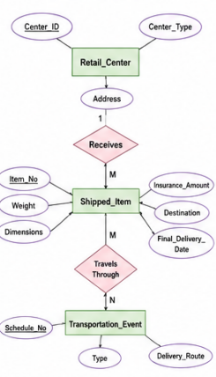
Explanation:
The UPS Product Tracking Information System is designed to track the movement of shipped items from the retail center to the final destination. The system stores information about each shipped item, the retail center where it is received, and the transportation events used for delivery.
The ER diagram contains the following entities:
- Shipped Item: Stores details such as Item Number, Weight, Dimensions, Insurance Amount, Destination, and Final Delivery Date. The Item Number is the Primary Key because it uniquely identifies each shipped item.
- Retail Center: Stores details like Center ID, Center Type, and Address. Every shipped item is received at one retail center, while a retail center can receive many shipped items. Therefore, the relationship between Retail Center and Shipped Item is One-to-Many (1:M).
- Transportation Event: Stores details such as Schedule Number, Type (Flight/Truck), and Delivery Route. A shipped item may travel through multiple transportation events, and each transportation event can carry multiple shipped items. Hence, the relationship between Shipped Item and Transportation Event is Many-to-Many (M:N).
Conclution:
This ER model helps UPS efficiently manage package tracking, monitor transportation, and reduce data redundancy. It ensures that every shipped item can be tracked accurately from the retail center to its final destination.

Q2. Course Management System

Entities
Course
- C_Number (PK)
- Name
- Department
Section (Weak Entity)
- S_Number (Partial Key)
- Enrollment
Room
- R_Number (PK)
- Capacity
- Building
Exam
- Exam_ID (PK)
- Time

Relationships
- Course has Section (1:M)
- Section scheduled in Room (M:1)
- Section has Exam (1:1)

ER Diagram

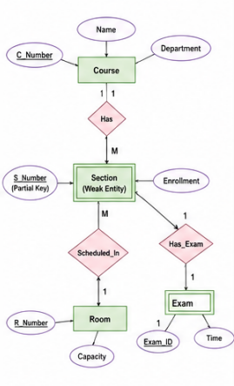

Explanation:
The Course Management System is used to manage information about courses, sections, classrooms, and final exams in a university. Instead of storing all details in a single Exam entity, separate entities are created to reduce data redundancy and improve data organization.
The ER diagram consists of the following entities:
- Course: Stores details such as Course Number (Primary Key), Course Name, and Department. A course can have multiple sections.
- Section (Weak Entity): Stores Section Number and Enrollment. It is called a weak entity because a section cannot exist without a course. Each section belongs to exactly one course.
- Room: Stores Room Number (Primary Key), Capacity, and Building. Each section is assigned to a room for conducting the final examination.
- Exam: Stores details of the final examination, such as Exam ID (Primary Key) and Exam Time. Each section has one final exam.

Conclusion
By separating Course, Section, Room, and Exam into different entities, the database becomes more organized, avoids duplication of data, and makes exam scheduling easier and more efficient.

Q3. University Registrar's Office Management System

Entities
Course
- Course_No (PK)
- Title
- Credits
- Syllabus
- Prerequisites
Course_Offering
- Offering_ID (PK)
- Year
- Semester
- Section_No
- Timings
- Classroom
Student
- Student_ID (PK)
- Name
- Program
Instructor
- Instructor_ID (PK)
- Name
- Department
- Title

Relationships
- Course has Course Offering (1:M)
- Instructor teaches Course Offering (1:M)
- Student enrolls in Course Offering (M:N)
- Enrollment contains Grade

ER Diagram:

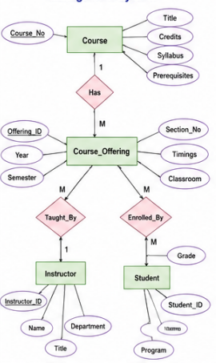

Explanation
The University Registrar's Office Management System is designed to manage information about courses, course offerings, students, instructors, and student enrollments. It helps the registrar maintain academic records, assign instructors, schedule classes, and record student grades efficiently.
The ER diagram consists of the following entities:
- Course: Stores details such as Course Number (Primary Key), Title, Credits, Syllabus, and Prerequisites. A course can be offered in different semesters.
- Course Offering: Stores information such as Year, Semester, Section Number, Timings, and Classroom. Each course offering belongs to one course and is taught by one or more instructors.
- Student: Stores Student ID (Primary Key), Name, and Program. A student can enroll in multiple course offerings.
- Instructor: Stores Instructor ID (Primary Key), Name, Department, and Title. An instructor can teach one or more course offerings.

Conclusion
This ER model efficiently organizes course details, student enrollment, instructor assignments, and grades. It reduces data redundancy and helps the university manage academic records accurately and efficiently.

Q4. Hospital Management System

Entities
Patient
- SS# (PK)
- Name
- Insurance
Physician
- Physician_Name (PK)
- Specialization
Test_Log
- Test_ID (PK)
- Test_Name
- Date
- Time
Patient_History
- History_ID (PK)
- Test_Name
- Date

Relationships
- Physician treats Patient (M:N)
- Patient has Test_Log (1:M)
- Patient has Patient_History (1:M)

1. PATIENT Table
SS# (PK) | Name | Insurance
P101 | Arun Kumar | Star Health
P102 | Meena | LIC Health
P103 | Ravi | ICICI Lombard

2. PHYSICIAN Table
Physician_Name (PK) | Specialization
Dr. Rajesh | Cardiologist
Dr. Priya | Neurologist
Dr. Kumar | Orthopedic

3. TEST_LOG Table
SS# (FK) | Test_Name | Date | Time
P101 | Blood Test | 10-07-2026 | 09:30 AM
P102 | ECG | 10-07-2026 | 11:00 AM
P103 | X-Ray | 11-07-2026 | 02:00 PM

4. DOCTOR_PATIENT Table
Physician_Name (FK) | SS# (FK)
Dr. Rajesh | P101
Dr. Priya | P102
Dr. Kumar | P103

5. PATIENT_HISTORY Table
SS# (FK) | Test_Name | Date
P101 | Blood Test | 10-07-2026
P102 | ECG | 10-07-2026
P103 | X-Ray | 11-07-2026

Primary Keys (PK)
- Patient: SS#
- Physician: Physician_Name

Foreign Keys (FK)
- Test_Log.SS# → Patient.SS#
- Doctor_Patient.SS# → Patient.SS#
- Doctor_Patient.Physician_Name → Physician.Physician_Name
- Patient_History.SS# → Patient.SS#
Explanation:
The Hospital Management System is designed to maintain information about patients, doctors, medical tests, and patient medical history. It helps hospitals manage patient records, assign doctors, store test details, and maintain treatment history efficiently.
The ER diagram consists of the following entities:
- Patient: Stores details such as SS# (Primary Key), Name, and Insurance. Each patient is uniquely identified by the SS#.
- Physician: Stores details such as Physician Name (Primary Key) and Specialization. A physician can treat multiple patients.
- Test_Log: Stores information about the tests conducted for patients, including SS#, Test Name, Date, and Time. A patient can have multiple test records.
- Patient_History: Stores previous medical test records of a patient, including SS#, Test Name, and Date.

Conclusion
This ER model helps the hospital efficiently manage patient information, doctor assignments, medical tests, and treatment history. It improves data organization, reduces redundancy, and ensures accurate maintenance of hospital records.

Q5. Company Project Management System

Entities
Department
- Dept_ID (PK)
- Dept_Name
- Location
Employee
- SSN (PK)
- Name
- Address
- Salary
- Sex
- Birth_Date
Project
- Project_No (PK)
- Project_Name
- Location
Dependent
- Dependent_Name
- Birth_Date
- Relationship

Relationships
- Department manages Project (1:M)
- Department employs Employee (1:M)
- Employee works on Project (M:N)
- Employee supervises Employee (1:M)
- Employee has Dependents (1:M)

ER Diagram

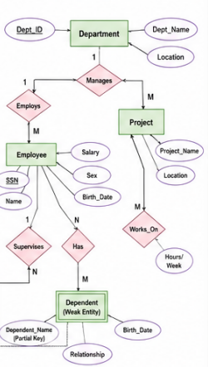

Explanation
The Company Project Management System is designed to manage information about departments, employees, projects, and dependents. It helps the company organize departments, assign employees to projects, record managers, and maintain employee details efficiently.
The ER diagram consists of the following entities:
- Department: Stores details such as Department Name (Primary Key), Department ID, and Location. Each department is managed by one employee and can have multiple locations.
- Employee: Stores details such as SSN (Primary Key), Name, Address, Salary, Sex, and Birth Date. Every employee belongs to one department and may work on multiple projects. Each employee also has an immediate supervisor.
- Project: Stores details such as Project Number (Primary Key), Project Name, and Location. A department controls multiple projects, and employees can work on one or more projects.
- Dependent: Stores details such as Dependent Name, Birth Date, and Relationship. Dependents are maintained for employee health insurance purposes and depend on the employee.

Conclusion
This ER model effectively represents the company's organizational structure by managing departments, employees, projects, supervisors, and dependents. It reduces data redundancy and ensures efficient project and employee management.

Q6. Explain Schema and Instance with examples. Distinguish between Logical Schema, Physical Schema and View Schema.

Schema
A schema is the overall logical structure or blueprint of a database. It defines the tables, attributes, relationships, constraints, and data types. A schema is designed once and changes very rarely.
Example:
STUDENT(Roll_No, Name, Department, Age)
This is the schema because it shows the structure of the table.

Instance
An instance is the actual data stored in the database at a particular point in time. It changes frequently whenever records are inserted, updated, or deleted.
Example:
Roll_No | Name | Department | Age
101 | Arjun | CSE | 20
102 | Meena | ECE | 21
103 | Ravi | IT | 19
This table represents one instance of the STUDENT database.

Difference between Schema and Instance
Schema | Instance
Blueprint of database | Actual data stored
Changes rarely | Changes frequently
Defines structure | Contains records
Called Intension | Called Extension

Types of Schema

1. Logical Schema (Conceptual Schema)
- Describes the complete logical structure of the database.
- Contains tables, attributes, relationships and constraints.
- Independent of physical storage.
Example: STUDENT(Roll_No, Name, Department)

2. Physical Schema (Internal Schema)
- Describes how data is physically stored in memory.
- Includes file organization, indexing and storage methods.
Example: B+ Tree Index, Hashing, Disk Blocks.

3. View Schema (External Schema)
- Shows only the data required by a particular user.
- Improves security by hiding unnecessary information.
Example: Faculty can view Student Name and Marks but not Salary or Personal Details.

Q7. Identify the entities, attributes and relationships for a Bank Management System and construct its ER diagram.

Entities

Customer
- Customer_ID (Primary Key)
- Name
- Address
- Phone

Account
- Account_No (Primary Key)
- Account_Type
- Balance
- Open_Date

Branch
- Branch_ID (Primary Key)
- Branch_Name
- Address

Transaction
- Transaction_ID (Primary Key)
- Date
- Amount
- Transaction_Type

Relationships
- Customer owns Account (1:M)
- Branch maintains Account (1:M)
- Account has Transaction (1:M)

ER Diagram:

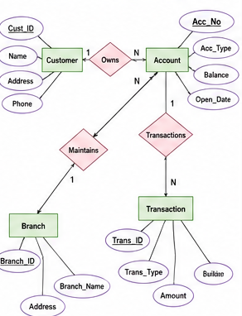

Explanation
The Bank Management System is designed to maintain information about customers, accounts, branches, and transactions. It helps the bank securely manage customer accounts, process transactions, and maintain accurate financial records.
The ER diagram consists of the following entities:
- Customer: Stores details such as Customer_ID (Primary Key), Name, Address, and Phone Number. A customer can own one or more bank accounts.
- Account: Stores details such as Account_Number (Primary Key), Account_Type, Balance, and Opening_Date. Each account belongs to one customer and is maintained by a branch.
- Branch: Stores details such as Branch_ID (Primary Key), Branch_Name, and Address. A branch manages multiple customer accounts.
- Transaction: Stores details such as Transaction_ID (Primary Key), Transaction_Date, Transaction_Type (Deposit/Withdrawal), and Amount. Every transaction is linked to a specific account.

Conclusion
The ER model for the Bank Management System organizes customer, account, branch, and transaction details efficiently. It reduces data redundancy, improves security, and enables accurate management of banking operations.

Q8. Explain the Extended ER (EER) Model. Describe Generalization, Specialization and Aggregation.

Extended ER (EER) Model
The Extended Entity Relationship (EER) Model is an advanced version of the ER model. It includes additional concepts such as generalization, specialization, inheritance, aggregation and categories, making it suitable for modeling complex real-world databases.

1. Generalization
Generalization is a bottom-up approach in which multiple lower-level entities having common properties are combined into a higher-level entity called a superclass.
Example:
Manager, Clerk and Engineer → Employee

2. Specialization
Specialization is a top-down approach where one higher-level entity is divided into several lower-level entities based on specific characteristics.
Example:
Employee → Manager, Engineer, Clerk

3. Aggregation
Aggregation treats a relationship between entities as a higher-level entity so that it can participate in another relationship.
Example:
Employee works on Project.
The relationship Works_On can be aggregated and supervised by a Manager.
Advantages of EER Model
- Represents complex data accurately.
- Supports inheritance.
- Reduces redundancy.
- Improves database design.

EER MODEL
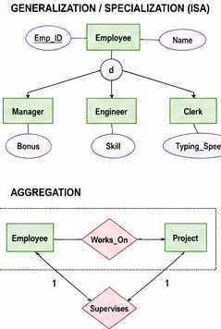

Advantages of the EER Model
- Represents complex real-world data more accurately.
- Supports inheritance through generalization and specialization.
- Reduces data redundancy.
- Improves database design and flexibility.

Conclusion
The EER model extends the basic ER model by introducing Generalization, Specialization, and Aggregation, making it more suitable for designing complex database systems with better organization and efficient data management.

Q9. Design an EER Diagram for a Hospital Management System incorporating inheritance and weak entities.

Superclass

Person
- Person_ID (Primary Key)
- Name
- Address

Subclasses (Inheritance)

Patient
- Insurance_No

Doctor
- Specialization
Both Patient and Doctor inherit Name and Address from Person.

Weak Entity

Test_Result
- Result_ID (Partial Key)
- Result_Value
- Result_Date
Test_Result depends on the Test entity and cannot exist independently.

Other Entity

Test
- Test_ID
- Test_Name
- Cost

Relationships
- Patient consults Doctor (M:N)
- Patient undergoes Test (1:M)
- Test has Test_Result (1:1)
- Test_Result is a Weak Entity.
EER Diagram:
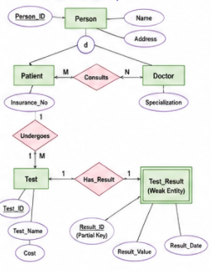

Conclusion
The EER model improves the Hospital Management System by using inheritance to avoid repeating common attributes in Patient and Doctor, and weak entities to represent dependent data like Test_Result. This makes the database more organized, flexible, and reduces data redundancy.

Q10. Explain the role of a DBA (Database Administrator) and the responsibilities associated with the position.

Database Administrator (DBA)
A Database Administrator (DBA) is a person responsible for installing, maintaining, securing and managing the database management system. The DBA ensures that the database is available, secure and performs efficiently.
Responsibilities of DBA
- Database Design
  - Designs database structure, tables and relationships.
- Installation and Configuration
  - Installs and configures DBMS software.
- Security Management
  - Creates user accounts.
  - Grants and revokes permissions.
  - Protects data from unauthorized access.
- Backup and Recovery
  - Performs regular backups.
  - Restores data after failures.
- Performance Tuning
  - Optimizes queries.
  - Creates indexes.
  - Improves database speed.
- Data Integrity
  - Ensures data is accurate, consistent and reliable.
- Concurrency Control
  - Manages multiple users accessing the database simultaneously.
- Monitoring and Maintenance
  - Monitors database health.
  - Updates software and fixes issues.
- Storage Management
  - Allocates storage efficiently.
  - Monitors disk usage.

Conclusion
A DBA plays a vital role in ensuring that the database is secure, reliable, available and performs efficiently, making database operations smooth for users and organizations.

